

2026 GOVERNMENT OF IRELAND POSTGRADUATE SCHOLARSHIP SCHEME

SUPERVISOR’S GUIDE TO THE ONLINE SYSTEM

Key Dates
Call Open: 12:00 (Irish time) 11 September 2025
FAQ deadline: 16:00 (Irish time) 16 October 2025
Applicant deadline: 16:00 (Irish time) 23 October 2025
Supervisor deadline: 16:00 (Irish time) 06 November 2025
Research Office Endorsement deadline: 16:00 (Irish time) 13 November 2025
Call outcome: End of April 2026
Award start date: 01 September 2026

Due to heavy server traffic on the day of the applicant and supervisor deadlines, all participants are strongly advised to submit their forms well in advance of the relevant deadline. The supervisor’s form cannot be submitted once the deadline has passed.

Help with technical issues
- This document is provided to assist you in submitting a supervisor’s reference form for applications under the 2026 Government of Ireland Postgraduate Scholarship Scheme. Please read it carefully before submitting your reference form online. Research Ireland will only accept reference forms submitted through the online application system. Please do not send your reference form to Research Ireland by email or in hard copy.
- Please ensure that the email address noreply@researchireland.ie is on your ‘safe senders’ list. You may need to check with your IT department to ensure there is no issue with your organisation’s internal firewall.
- If you experience any technical issues, please clear the cache in your browser and continue. If the issue persists, please contact system@researchireland.ie. Where possible, please include:
    - the project ID of the application,
    - the browser you are using
    - and, if appropriate, a screenshot of any error messages.
- The grants management system is only compatible with the two most recent versions of Firefox, Chrome, Internet Explorer and Safari.

Logging into the online system

- Each Eligible Research Body is responsible for registering their supervisors on the online system. When initially registered, you should have received an email containing your username (which is your email address), password, and a link to the login page. If you are not yet registered on the online system, please contact your research office to find out why.
- If you have lost or forgotten your password, navigate to the login page above and click the ‘forgot password?’ icon. A system-generated password will be forwarded to your email address. If you do not receive this email, please check your spam folder. Please note that it may take up to 15 minutes to receive the email containing your new password.
- You will not be able to create and submit your supervisor form until the applicant has submitted their application. Once logged in, the home screen will be displayed with the following icons:
- Open Calls
- Draft Applications Assigned
- Assigned Applications
- Activities Pending Action
- Submitted Activities

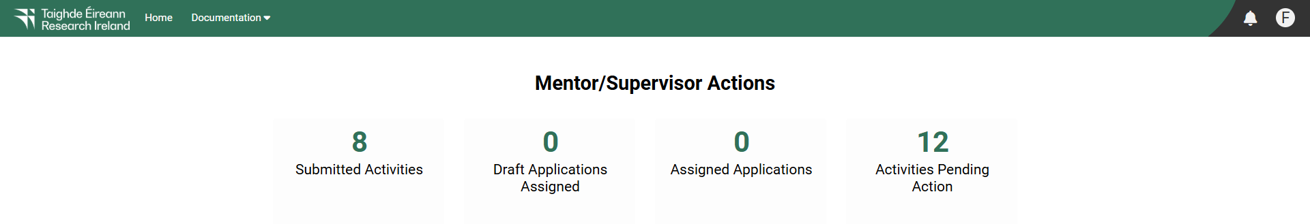

- Details of the application can be previewed while it is in draft status by clicking on the ‘Activities Pending Action’ icon.
- Once the ‘Activities pending Action’ icon has opened, applications requiring activity should appear under the following headings:
            - #
            - Project ID
            - Project Title
            - Status
            - Application Type
            - Irish research body
            - View Application PDF
            - Activity Type

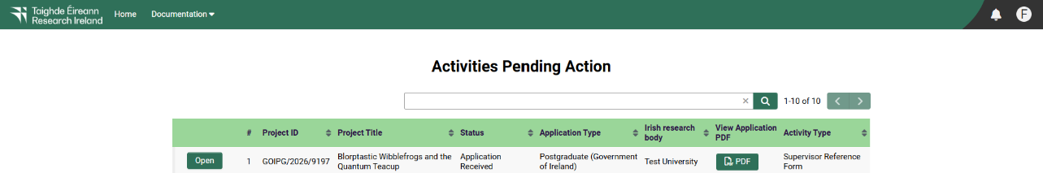

- Once the applicant has submitted their application, you should be able to log in and submit your supervisor form. Click on the ‘activities pending action’ icon on the home page in order to view any postdoctoral applications awaiting your reference. If you wish to view the submitted application , please click on the ‘View Application PDF’ button.
- The status of the application to which you have been assigned is also detailed on this page under the ‘Status’ heading.

Creating and EDITING your SUPERVISOR form

- Academic Supervisors may act as Primary Academic Supervisor for no more than one applicant to the Government of Ireland Postgraduate Scholarship programme. As such, Primary Academic Supervisors should endorse only one submitted application. If the Research Office endorses multiple applications with the same primary academic supervisor, all applications will be deemed ineligible. There is no restriction on the number of applications for which a supervisor may serve as secondary or co-supervisor.
- Applicants are instructed by Research Ireland to gain the consent of any proposed supervisor before adding them to an application. While the majority of applicants follow these instructions, there are instances where applicants assign primary academic supervisors to applications without obtaining their consent. If you have received an email in error and do not know the applicant, they may have mistakenly associated you with their application. You may find it reassuring to know that the applicant’s error will not have any detrimental effect on future Research Ireland applications submitted by you, or on the application that is legitimately assigned to you. In cases where applications have not received a supervisor reference, they do not proceed to the Research Office endorsement decision stage nor the assessment stage.
- Once the applicant has submitted their application, you should be able to log in and submit your supervisor form. If you wish to view the application as submitted, please click on the ‘View Application PDF’ button.
- Once you have clicked ‘open’, the reference form will open in edit mode. You can then complete your reference. This reference is an essential element of the application, and all sections should be completed in full. The information you have entered can be saved at any time by clicking on the ‘save draft’ button at the bottom of the screen. Please do not navigate to any other tab or browser until all the information you have entered has been saved.
- Research Ireland maintains ‘gender-blinding’ of applications for evaluation purposes to mitigate any gender bias in the assessment of excellence. As such, our assessors review applications that are anonymous and free from pronouns or other words which would identify the applicant’s gender. In order to comply with these guidelines, we ask that you use ‘the applicant’, ‘s/he/they’ and ‘his/her/their’ when providing your observations rather than the person’s name or pronouns which would identify their gender.
- Supervisors can access and edit their forms as often as necessary prior to submission by logging into the ‘activities pending action’ section of the online system and clicking on the ‘edit’ button.
- The Primary Supervisor Form may be submitted in Irish. Supervisors are encouraged to upload an English translation where applicable. Please note that any files uploaded in the ‘English Translation’ section cannot be removed once uploaded.

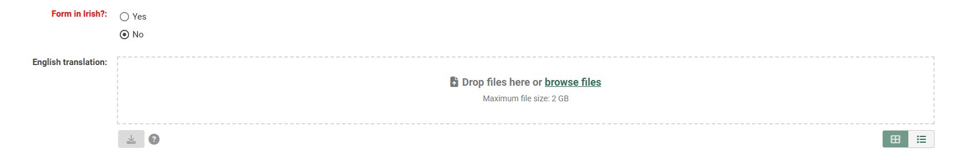

- The ‘English translation’ section should only be used to provide an English translation of the supervisor form that has been submitted in Irish and not for upload of letters of support or any other documentation that has not been specifically requested. Should Primary Supervisors use this section to upload letters of support or any other documentation that has not been specifically requested, the application will be rendered ineligible.

Submitting your SUPERVISOR form
- Click ‘submit’ to submit your reference form.
- A message stating ‘No further changes can be made once the reference is submitted. Do you wish to proceed to submit the reference now?’.
- If you wish to proceed and submit the reference please select the ‘OK’ button displayed below the message. If you do not wish to proceed with the submission, please select the ‘Cancel’ button displayed below this message.

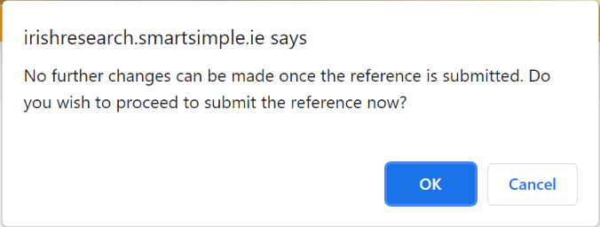
- Please note that no changes can be made to a reference form once it has been submitted. It is therefore vital that you are completely satisfied with the content of your form prior to final submission.
- Once submitted, you will receive an automated email confirming receipt of your form.
- A message stating the following will be displayed once your form has been submitted successfully: ‘Supervisor Form Submission Successful’ with the Project ID and Project Title listed below it.

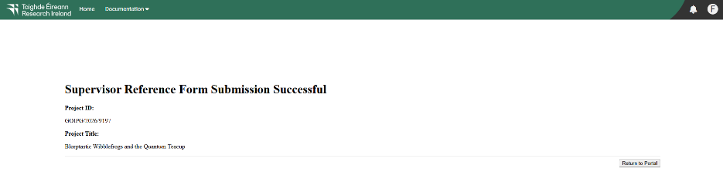

Effects of submitting your supervisor form

- Once submitted, you can view your form by clicking on the ‘submitted activities’ icon on your home page.
- Click the ‘view’ button beside the relevant application. Please note that you will not be able to edit the form at this stage.
- The applicant’s online profile will be updated to confirm your form has been submitted.
- Please note that the supervisor’s form will not be visible to the applicant.

